Batch: B1 Roll No.: 1711072

Experiment / assignment / tutorial No. 1

Grade: AA / AB / BB / BC / CC / CD /DD

Signature of the Staff In-charge with date

Title: Study of component inside cabinet.

AIM: To study all basic components which are inside the cabinet
______________________________________________________________________
Expected OUTCOME of Experiment:

CO 1: To study different Hardware components of the system and its importance.
_____________________________________________________________________
Books/ Journals/ Websites referred:

- IBM- PC BY Govindrajalu, THM
_____________________________________________________________________
Pre Lab/ Prior Concepts:

A computer case also known as a computer chassis, tower, system unit, cabinet, base unit or simply case is the enclosure that contains most of the components of a computer (usually excluding the display, keyboard and mouse).
Cases are usually constructed from steel (often SECC — Steel, electrogalvanized, cold-rolled, coil) or aluminium. Plastic is sometimes used.
Cases can come in many different sizes (known as form factors). The size and shape of a computer case is usually determined by the form factor of the motherboard, since it is the largest component of most computers. Consequently, personal computer form factors typically specify only the internal dimensions and layout of the case.
Computer cases usually include sheet metal enclosures for a power supply unit and drive bays, as well as a rear panel that can accommodate peripheral connectors protruding from the motherboard and expansion slots. Most cases also have a power button or switch, a reset button, and LEDs to indicate power status as well as hard drive and network activity (in some models). Some cases include built-in I/O ports (such as USB and headphone ports) on the front of the case. Such a case will also include the wires needed to connect these ports, switches and indicators to the motherboard.
Basic Components are as follows
- Motherboard
- CMOS
- CPU
- Memory (RAM)
- Power supply
- Hard disk
- CD-ROM, CD-RW, or DVD-ROM drive / Optical drive
- GPU
- Sound card
- Expansion slots
Motherboard:
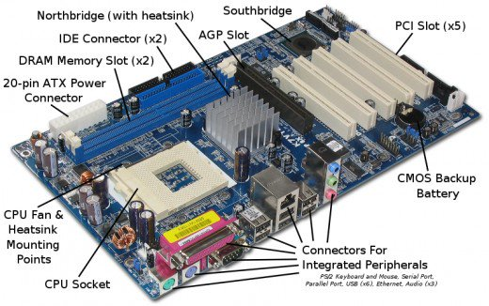
The motherboard is the body or mainframe of the computer, through which all other components interface. It is the central circuit board making up a complex electronic system. A motherboard provides the electrical connections by which the other components of the system communicate. The mother board includes many components such as: central processing unit (CPU), random access memory (RAM), firmware, and internal and external buses.
CMOS:
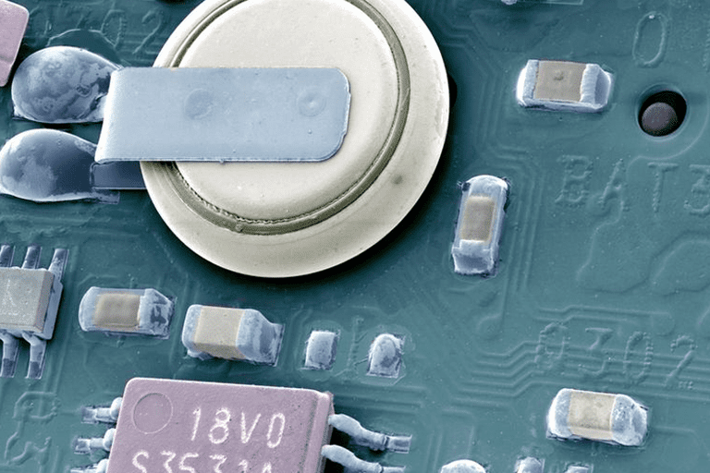
CMOS (complementary metal-oxide-semiconductor) is the term usually used to describe the small amount of memory on a computer motherboard that stores the BIOS settings. Some of these BIOS settings include the system time and date as well as hardware settings.
Most talk of CMOS involves clearing CMOS, which means to reset the BIOS settings to their default levels. This is a really easy task that's a great troubleshooting step for many types of computer problems. CMOS is sometimes referred to as Real-Time Clock (RTC), CMOS RAM, Non-Volatile RAM (NVRAM), Non-Volatile BIOS memory, or complementary-symmetry metal-oxide-semiconductor (COS-MOS). The CMOS is usually powered by a CR2032 cell battery, referred to as the CMOS battery. Most CMOS batteries will last the lifetime of a motherboard, up to 10 years in most cases, but will sometimes need to be replaced. Incorrect or slow system date and time and loss of BIOS settings are major signs of a dead or dying CMOS battery. Replacing them is as easy as swapping out the dead one for a new one.
The BIOS is a computer chip on the motherboard like CMOS except that its purpose is to communicate between the processor and other hardware components like the hard drive, USB ports, sound card, video card, and more. A computer without BIOS wouldn't understand how these pieces of the computer work together. CMOS is also a computer chip on the motherboard, or more specifically a RAM chip, which means it would normally lose the settings it's storing when the computer is shut down. However, the CMOS battery is used to provide constant power to the chip. When the computer first boots up, the BIOS pulls information from the CMOS chip to understand the hardware settings, time, and anything else that's stored in it.

CPU:
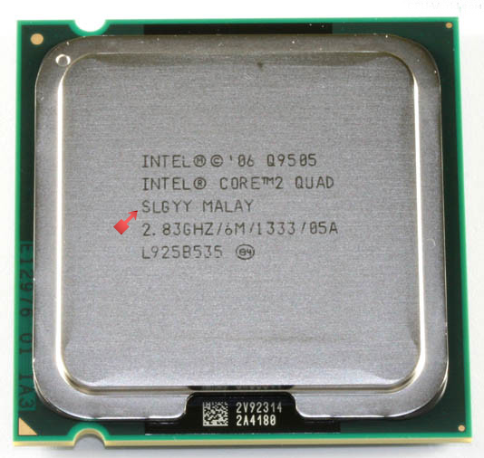
The Central Processing Unit (CPU; sometimes just called processor) is a machine that can execute computer programs. It is sometimes referred to as the brain of the computer. It comprises of registers, ALU, control unit and an internal bus. There are four steps that nearly all CPUs use in their operation: fetch, decode, execute, and write back. The first step, fetch, involves retrieving an instruction from program memory. In the decode step, the instruction is broken up into parts that have significance to other portions of the CPU. During the execute step various portions of the CPU, such as the arithmetic logic unit (ALU) and the floating point unit (FPU) are connected so they can perform the desired operation. The final step, write back, simply writes back the results of the execute step to some form of memory. There is usually a fan and a heat-sink mounted on the processor to ensure sure that it doesn’t overheat.
Main memory (RAM):
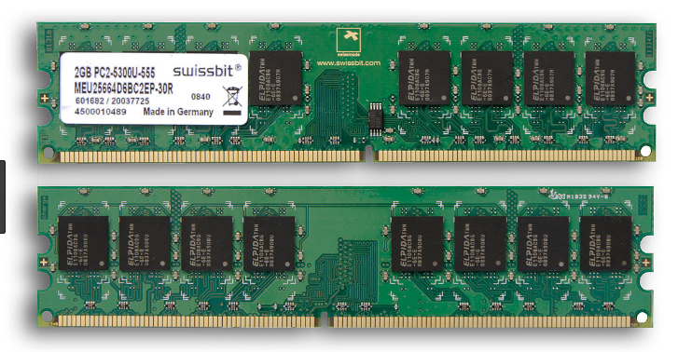
Random access memory (RAM) is fast-access memory that is cleared when the computer is power-down. RAM attaches directly to the motherboard, and is used to store programs that are currently running. RAM is a set of integrated circuits that allow the stored data to be accessed in any order (why it is called random). There are many different types of RAM. Distinctions between these different types include: writeable vs. read-only, static vs. dynamic, volatile vs. non-volatile, etc.
Early computers used relays, mechanical counters or delay lines for main memory functions. Ultrasonic delay lines could only reproduce data in the order it was written. Drum memory could be expanded at relatively low cost but efficient retrieval of memory items required knowledge of the physical layout of the drum to optimize speed. Latches built out of vacuum tube triodes, and later, out of discrete transistors, were used for smaller and faster memories such as registers. Such registers were relatively large and too costly to use for large amounts of data; generally only a few dozen or few hundred bits of such memory could be provided.
The first practical form of random-access memory was the Williams tube starting in 1947. It stored data as electrically charged spots on the face of a cathode ray tube. Since the electron beam of the CRT could read and write the spots on the tube in any order, memory was random access. The capacity of the Williams tube was a few hundred to around a thousand bits, but it was much smaller, faster, and more power-efficient than using individual vacuum tube latches. Developed at the University of Manchester in England, the Williams tube provided the medium on which the first electronically stored program was implemented in the Manchester Baby computer, which first successfully ran a program on 21 June 1948. In fact, rather than the Williams tube memory being designed for the Baby, the Baby was a testbed to demonstrate the reliability of the memory.

Power supply:
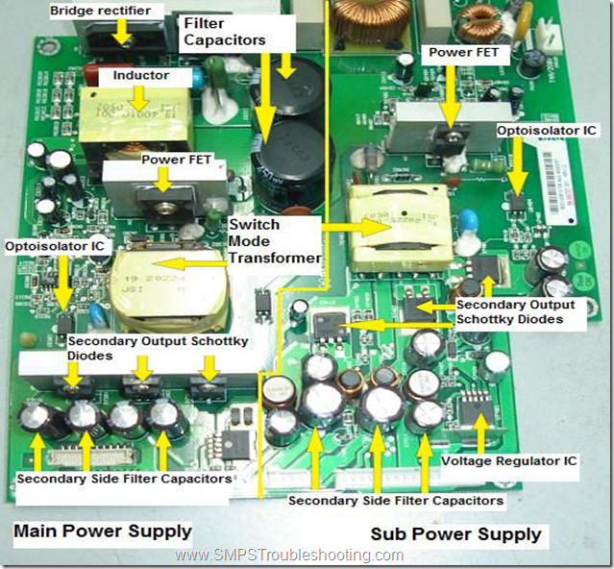
The power supply also referred to as SMPS (Switched Mode Power Supply) or PSU (Power Supply Unit), is the device that supplies power to all the components in the computer. Its case holds a transformer, voltage control, and (usually) a cooling fan. The power supply converts about 100-120 volts of AC power to low-voltage DC power for the internal components to use. It usually sits at the top corner of the cabinet, and has a small fan attached to it to prevent overheating. The most common computer power supplies are built to conform to the ATX form factor. This enables different power supplies to be interchangeable with different components inside the computer. ATX power supplies also are designed to turn on and off using a signal from the motherboard, and provide support for modern functions such as standby mode.

Hard disk:
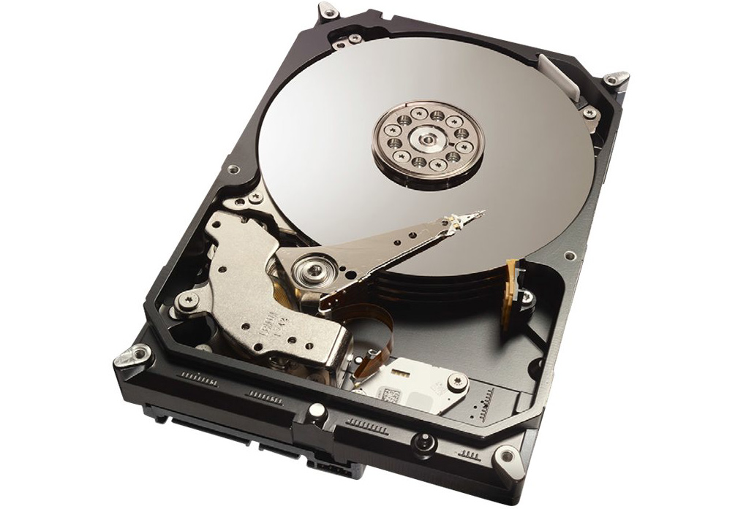
A hard disk drive (HDD) is a non-volatile storage device which stores digitally encoded data on rapidly rotating platters with magnetic surfaces. It is usually fitted into a slot above the motherboard. It typically measures between 2.5” and 3.5”. This is where all information is stored permanently and can be accessed, altered or deleted as and when required. Typical desktop hard disk drives store between 120 and 400GB, rotate at 7,200 rpm, and have a media transfer rate of 1 Gbit/s or higher. Hard disk drives are accessed over one of a number of bus types, including parallel ATA(also called IDE), Serial ATA (SATA), SCSI, Serial Attached SCSI, and Fiber Channel.
Solid State Drive:
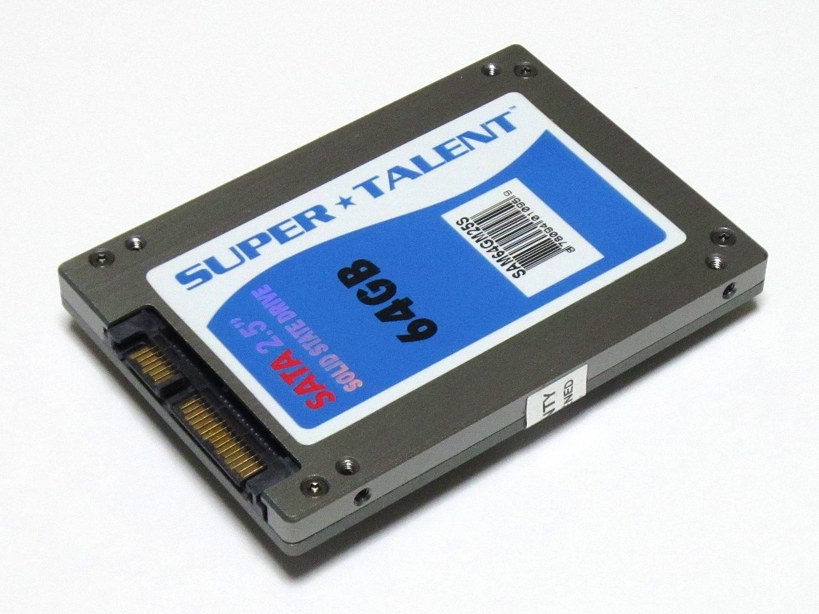
A solid-state drive (SSD) is a solid-state storage device that uses integrated circuit assemblies as memory to store data persistently. It is also sometimes called solid-state disk, although SSDs do not have physical disks. SSDs may use traditional hard disk drive (HDD) form-factors, protocols and file systems such as SATA, SAS and NTFS or FAT32 greatly simplifying usage of SSDs in computers, or Form factors, file systems and interfaces designed for SSDs, like mSATA, m.2, u.2, NVMe, Ruler SSD, PCIe and APFS or F2FS, often greatly improving performance and removing unnecessary features like defragmentation which can improve performance on HDDs but reduce the lifespan of SSDs.
SSDs have no moving mechanical components. This distinguishes them from conventional electromechanical drives such as hard disk drives (HDDs) or floppy disks, which contain spinning disks and movable read/write heads Compared with electromechanical drives, SSDs are typically more resistant to physical shock, run silently, have quicker access time and lower latency. While the price of SSDs has continued to decline over time, SSDs are (as of 2019) still more expensive per unit of storage than HDDs and are expected to continue to be so into the next decade.
As of 2017, most SSDs use 3D TLC NAND-based flash memory, which is a type of non-volatile memory that retains data when power is lost. For applications requiring fast access but not necessarily data persistence after power loss, SSDs may be constructed from random-access memory (RAM). Such devices may employ batteries as integrated power sources to retain data for a certain amount of time after external power is lost. Since 2018, some SSDs have 3D QLC (4 bit) NAND-based flash memory, which increases capacity and lowers costs, but at the expense of a lower endurance rating. For example, a 1 TB QLC SSD will have the same endurance rating as a 500 GB TLC (3 bit) SSD. High performance SSDs are made from SLC(1 bit) and 2 bit MLC NAND Flash, but these are probably expensive and have a low capacity, making them better suited for caches or where very high speeds are required, as SLC NAND is, for example, faster than QLC NAND.
However, all SSDs still store data in electrical charges, which slowly leak over time if left without power. This causes worn out drives (that have exceeded their endurance rating) to start losing data typically after one (if stored at 30 °C) to two (at 25 °C) years in storage; for new drives it takes longer. Therefore, SSDs are not suited for archival purposes. The only exception to this rule are SSDs based on 3D XPoint memory, which stores data not by storing electrical charges in cells, but by changing the electrical resistance of the cells. 3D XPoint however is a relatively new technology whose behavior over long periods of time is still unknown and thus it shouldn't be used for archival storage.
Hybrid drives or solid-state hybrid drives (SSHDs), such as Apple's Fusion Drive, combine the features of SSDs and HDDs in the same unit, containing a large hard disk drive and an SSD cache to improve performance of frequently accessed data.

Optical drive (CD-ROM/DVD-ROM drive):
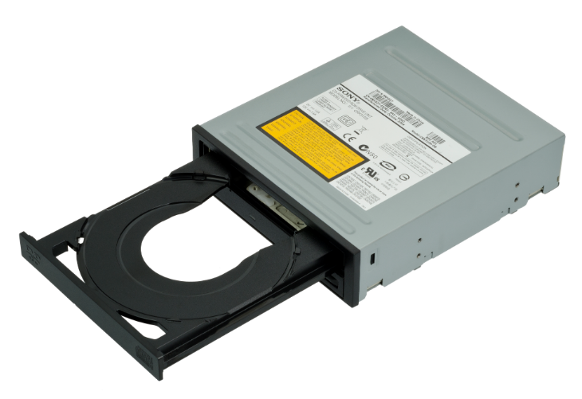
CD-ROM (compact disc read-only) and DVD-ROM (digital versatile disc read-only) drives are relatively high-capacity, removable media optical drives. It contains some lenses that project electromagnetic waves that are responsible for reading and writing data on optical discs.
GPU (Graphical Processor Unit):
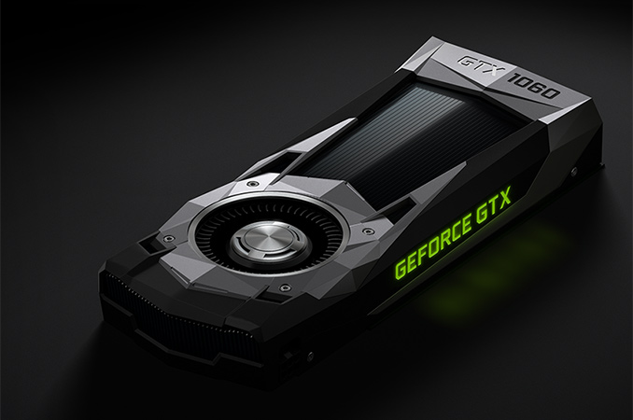
A graphics processing unit (GPU) is a specialized electronic circuit designed to rapidly manipulate and alter memory to accelerate the creation of images in a frame buffer intended for output to a display device. GPUs are used in embedded systems, mobile phones, personal computers, workstations, and game consoles. Modern GPUs are very efficient at manipulating computer graphics and image processing. Their highly parallel structure makes them more efficient than general-purpose CPUs for algorithms that process large blocks of data in parallel. In a personal computer, a GPU can be present on a video card or embedded on the motherboard. In certain CPUs, they are embedded on the CPU die.
The term GPU has been used from at least the 1980s, it was popularized by Nvidia in 1999, who marketed the GeForce 256 as "the world's first GPU". It was presented as a "single-chip processor with integrated transform, lighting, triangle setup/clipping, and rendering engines". Rival ATI Technologies coined the term "visual processing unit" or VPU with the release of the Radeon 9700 in 2002.
Sound card:
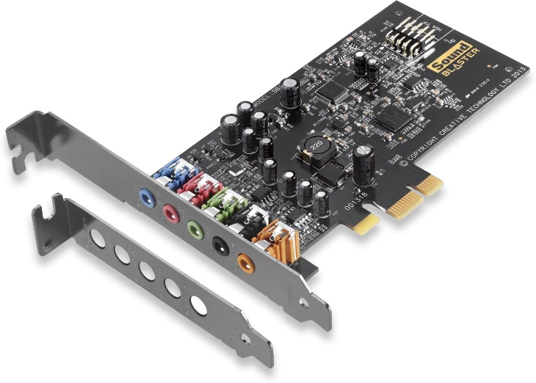
Alternatively referred to as an audio output device, sound board, or audio card, a sound card is an expansion card or IC for producing sound on a computer that can be heard through speakers or headphones. Although the computer does not need a sound device to function, they are included on every machine in one form or another, either in an expansion slot or built into the motherboard.
Expansion slots:
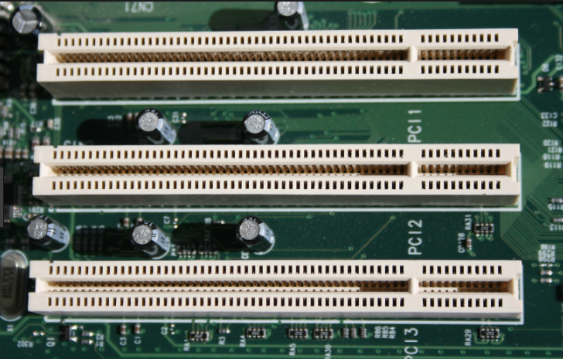
Alternatively referred to as a bus slot or expansion port, an expansion slot is a connection or port located inside a computer on the motherboard. It provides an installation point for a hardware expansion card to be connected. Video cards, sound cards, network cards, etc. can be connected to the motherboard via expansion slots. Today, the most commonly used expansion slot used and found on computer motherboards is the PCI Express expansion slot.
Components inside a laptop:
Overall, laptop and desktop computers are very similar. They have the same basic hardware, software and operating systems. The primary difference is how their components fit together. A laptop is much smaller and lighter than even the most compact PC tower. Its screen is an integrated part of the unit, as is its keyboard. Instead of a spacious case with lots of room for air circulation, a laptop uses a small, flat design in which all the pieces fit together snugly.
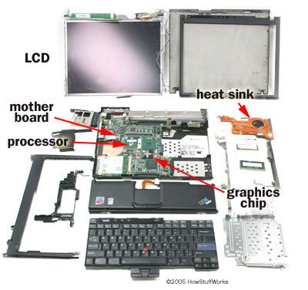
Processor
The central processing unit (CPU) is the controlling component of the laptop computer. Processor speeds for computers are measured in gigahertz (GHz). Multi-core processors have more than one processor core on the same chip. Speed ratings for these processors indicate the speed of each individual core. The faster the speed, and the more cores the laptop processor has, the more tasks the laptop can do simultaneously.

Hard Drive
The hard drive is the memory storage of your laptop. A big hard drive allows you to install more, larger programs and save more files. Today’s high-performance laptop computers have hard drives with hundreds of gigabytes of storage space. Typical hard drives run at 5,400 rpm, but you can get a performance boost with a 7,200 or even 10,000 rpm hard drive.
System Memory
Random access memory (RAM) is one of the main components that will make your laptop run faster. A lot of RAM will allow your computer to run more programs simultaneously, as well as work with larger multimedia programs. A Web-browsing laptop needs about 2 GB of RAM, while an entertainment laptop can have anywhere from 4 to 8 GB.
Screen
Laptop screens use thin liquid crystal display (LCD) screens. You get the clearest picture running your laptop display at the native resolution, which is the resolution at which the image matches the exact number of pixels on the screen. The higher the laptop screen’s native resolution, the more detailed the picture quality will be.
Optical Drive
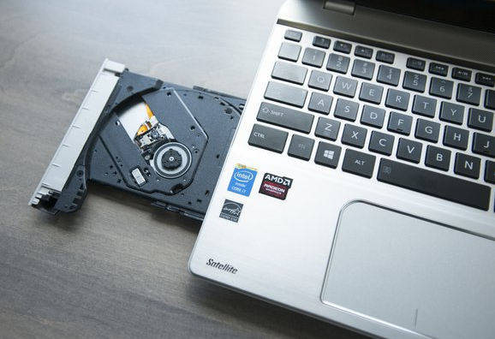
The laptop’s optical drive is its DVD or CD drive. Most new laptops come with a DVD+/-RW drive, also called the burner, which reads and writes blank DVDs and CDs in all formats. These are handy for backing up your important files as well as putting your home videos onto a disc. Some smaller laptops save on space and weight by not having an optical drive to, but the vast majority of notebook computers will have them.

External Ports
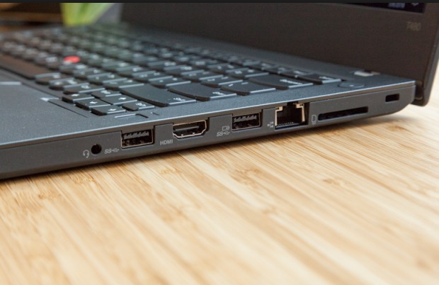
The number of external ports varies from laptop to laptop. All will have at least a couple of USB ports. You might also look for a VGA port if you want to connect to a separate monitor or a projector. A laptop computer may also feature memory card slots for MMC and SD cards.
Networking
An Ethernet port will allow you to connect through an Ethernet cable to a network. Wireless connections, using a wireless-G or wireless-N signal, are nearly universal in newer laptops.
Video Card
Also called graphics cards, video cards generate graphics on your laptop display. All laptop CPUs have a graphics controller, which allows the computer to display basic video and graphics. A video card, however, is an extra device that takes the load off the processor, allowing the laptop to run smoothly and quickly when playing movies or working with photos. Some video cards have their own system memory, which makes for faster, more seamless performance.

Conclusion: The study of different components internal to a personal computer (CPU), and laptop was successfully done.
Date: 18/1/2019 Signature of faculty in-charge

